| **Test Name** | High Tank Level Sensor Reading is Ignored [Automation Off] |
| --- | --- |
| **Use Case Tested:** | Manually turn the pump on |
| **Test Description:** | This test verifies that when automation is turned off, the dashboard will ignore tank status that would trigger if automation was on |
| **Pre-conditions** | Pump Not Running; System State of Pump: Not running; ThingsBoard has not asked the pump to start running via manual operation. |
| **Post-conditions** | No Change |
| **Notes:** |  |

|  | **TEST STEP** | **EXPECTED TEST RESULTS** |
| --- | --- | --- |
|  | Use Simulator to send tank sensor message with level 2.1 metres. |  |
|  | Check that no change is registered in dashboard | Dashboard logs tank level, doesn’t action low level. |

|  |  |  |  |  |  |
| --- | --- | --- | --- | --- | --- |
| **Test Data Table** | | | | | |
|  | **1** | **2** | **3** | **4** | **5** |
| [Data field 1] | [data set 1 input value for field 1] |  |  |  |  |
| [Data field 2] | [data set 1 input value for field 2] |  |  |  |  |
| [Data field 3] | [data set 1 input value for field 3] |  |  |  |  |

**Results**

05/09/2020

**SUCCESS!**

Dash logs 2.1m level. Nothing triggered.

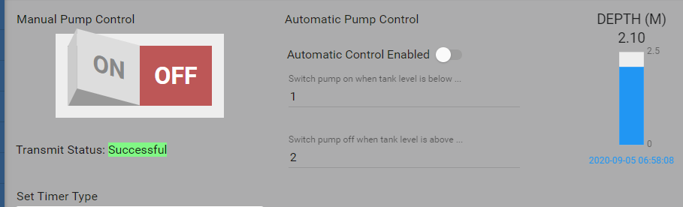

9/9/2020 – On site test at OAI.

Success.

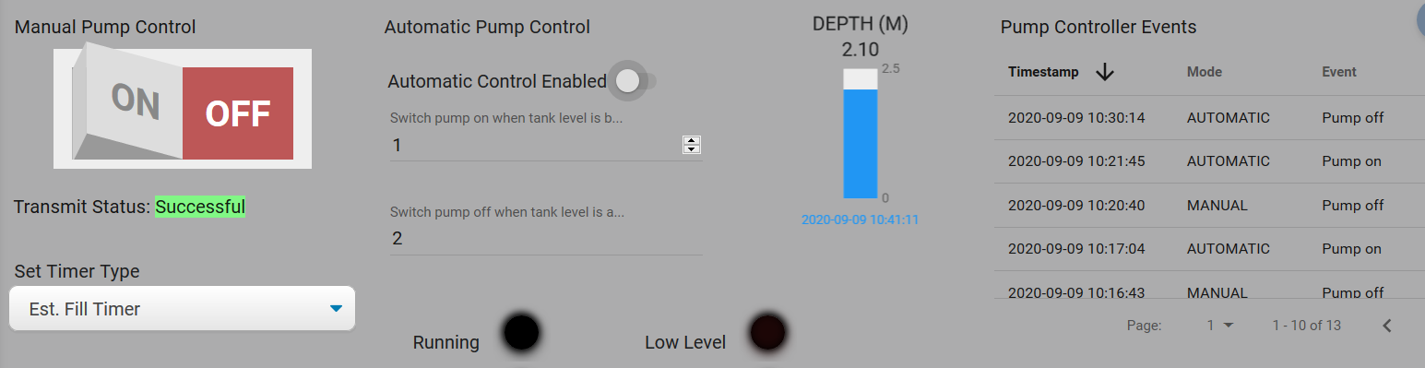

10:41:50.336 -> Send operator requested status message.

10:41:50.336 -> LoRaWAN will encode and send this message: {'pumpRunning':0,'boreLowLevel':0,'softStartFail':0,'pumpOverload':0,'controllerRestart':0,'highPressure':0,'noFlow':0}

10:41:50.336 -> Sending status byte: 00

10:41:52.452 -> EV_TXCOMPLETE (includes waiting for RX windows)